Diocesan Education Service

All you need to know about…
The Sacrament of Reconciliation

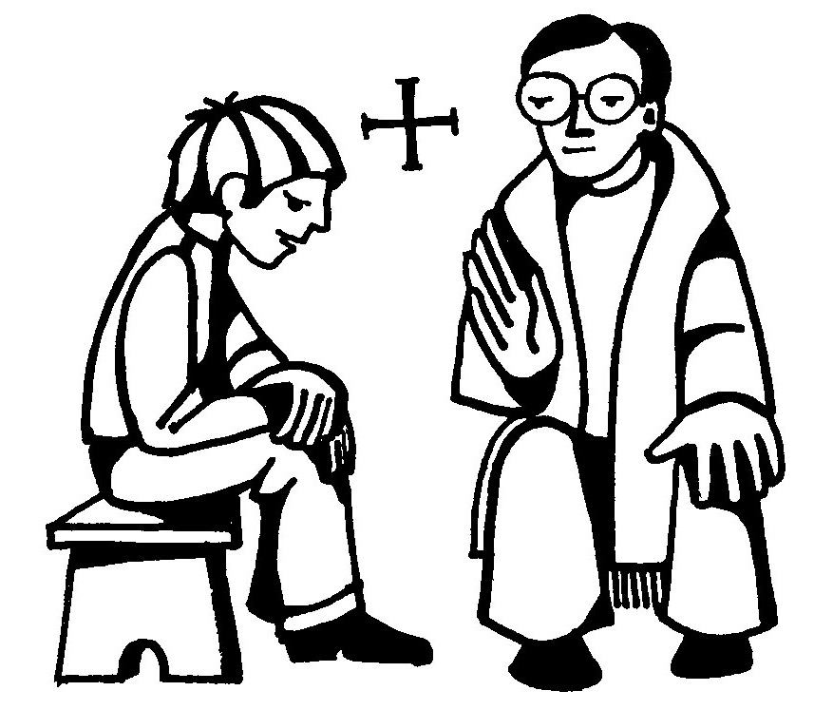
Diocesan Education Service
All you need to know about…
The Sacrament of Reconciliation
What is it and what is the purpose of the Sacrament of Reconciliation?
- Reconciliation is one of the seven Sacraments of the Church.
- It is one of the two sacraments of healing the other being the Sacrament of the Sick.
- Through the Sacrament of Reconciliation we receive God’s forgiveness for our sins his pardon and healing and reconciliation with the Church.
- Through Reconciliation we are absolved of our sins and through our subsequent acts of penance we can help repair the damage caused.
- Sin causes damage to our relationship with God, with other people and with the Church. In the Sacrament we experience God’s healing and forgiveness.
- It is also sometimes referred to as the Sacrament of Penance, of Forgiveness of Confession or of Conversion. All of these terms describe some aspect of the Sacrament and its effect. However ‘Reconciliation’ recognises the two part relationship between God, his Church and the person seeking the Sacrament and the healing which the Sacrament brings.
- The forgiveness of sins can only take place within the Sacrament of Reconciliation. Whilst during the Mass there is the Penitential Act, said during the Introductory Rite, and the Sign of Peace made before Holy Communion is received, these prayers and actions are not sacramental. They are an acknowledgement of our failings and a recognition that we need to ask for forgiveness. They also express our gratitude to God for the great mercy he shows us and our desire to be supported by the whole of the Communion of Saints (namely all members of God’s family: the members of the Church who have died and gone to heaven, those in purgatory and those of us here on Earth at this moment).
How did Reconciliation originate?
- The message of repentance is found in the teaching of St. John the Baptist who called people to repent and be baptised. Before beginning his ministry Jesus goes to John to be baptised. Jesus is revealed as God’s beloved Son and, as the Son of God, he will bring God’s forgiveness and reconciliation by his death and resurrection.
- Early in his ministry Jesus taught the disciples to ask for God’s forgiveness when they prayed. The prayer he taught them was the ‘Our Father’ and is the prayer still used today. In it we ask God to “Forgive us our trespasses as we forgive those who trespass against us” (Matthew 6:12, Luke 11:4).
- Jesus also spent much of his time ministering to those that were in need of healing not just of body but also those who were troubled in mind because of the way that they were living their lives (The Healing of the Paralysed Man: Matthew 9:1-7, Mark 2:1-12, Luke 5:17-26; Zacchaeus Luke 19:1-10). He also spent time teaching through the parables about the importance of seeking God’s forgiveness (The Unforgiving servant Matthew 18:21-36 The Prodigal Son Luke 15: 11- 32).
- As Jesus died on the cross he prayed to the Father “Forgive them, Father, for they do not know what they are doing” (Luke 23: 34).
- After the Resurrection, before he ascended into heaven, Jesus gave the disciples the authority to forgive sins (Luke 24:47, John 20:23). The disciples, as leaders of the early Church, passed this authority on through the ministry of priests where it has remained ever since.
When does Reconciliation take place?
- The Sacrament of Reconciliation can be first received when a child reaches the age of reason which the Church sees as 7 years old. In this Diocese it normally takes place when the child is in Y3 of school.
- Although there is not a specific time in the year when First Reconciliation takes place the Seasons of Advent and Lent are appropriate times as these are the times in the Church’s year when people reflect and focus upon how they can change to become better followers of Christ.
- A person cannot receive the Sacraments of First Eucharist or Confirmation before they have received the Sacrament of Reconciliation. Whilst Reconciliation is not a Sacrament of Initiation, it is necessary that it is received in preparation for these sacraments.
- First Reconciliation can take place at any stage in a person’s life.
- The precepts of the Church require Catholics to receive Holy Communion at least once a year, especially in the Season of Easter. In order to be ready to do this, they will need to receive the Sacrament of Reconciliation. This is called Easter Duties.
Where does Reconciliation take place?
- Traditionally Reconciliation takes place within the Confessional: a small room divided into two by a screen which is contained within the body of the Church. In this way neither the penitent nor the priest can see one another. The priest is seated in the Confessional whilst the unseen penitent kneels throughout.
- In recent years it has become a more common practice to receive the Sacrament of Reconciliation face-to-face with the priest. This may still happen in the Confessional if some of the partition has been removed but it can also take place anywhere else in the Church out of earshot from others. In this situation it is more likely that both are seated.
- Whilst Reconciliation usually takes place in Church a confession can be heard anywhere. Priests will often administer the Sacrament to those who are sick either in their homes or in hospital.

Can anyone receive the Sacrament of Reconciliation?
- A baptised member of the Catholic Church may receive the Sacrament of Reconciliation.
How many times can you receive the sacrament of Reconciliation?
- Reconciliation is a Sacrament which can be received as often as is necessary and at least once a year as the precepts require.
- Most parishes will provide opportunities for individual confession on a weekly basis.
- During the seasons of Advent and Lent parishes will usually offer a Service of Reconciliation whereby the congregation participate in an Examination of Conscience and then go to one of a number of priests available to have their individual Confession heard.
- In extreme circumstances of imminent peril a priest could offer General Absolution to a group of people all at the same time.
Who can celebrate the Sacrament of Reconciliation?
- Only an ordained bishop or priest can hear Confession.
Who has to be present at Reconciliation?
- Only the priest and the person going to receive Reconciliation are present.
What happens at the Sacrament of Reconciliation?
Examination of Conscience
- The Examination of Conscience is undertaken before going to confession. It can either be done alone or within a communal Service of Reconciliation.
This is a reflective process whereby the person seeking forgiveness spends some time in quiet prayer thinking about the times they have sinned. Some people may read from Scripture or, if at a Service, listen to Scripture. Some people may reflect upon the Ten Commandments or The Beatitudes and use them as prompts to think about their own words and actions. In a Service the celebrant may ask a series of questions to which people can make their own silent response.
Celebration of the Sacrament
Confession
- The penitent goes to the priest where they are welcomed and together they make the Sign of the Cross.
- The penitent tells the priest how long it has been since they last went to Confession or that it is their first confession. Adults may also state something about their life e.g. they are married, have children etc.
- The penitent then confesses their sins.
If the Sacrament is taking place in the screened Confessional neither person can see the other. This is done to maintain the anonymity of the penitent and it also acts as a reminder that the priest is there as the person of Jesus. In effect we are talking directly to Jesus.
Anything which is said to the priest within the Sacrament of Reconciliation cannot, under any circumstance, be repeated or shared with any other person including the police or even in a Court of Law.
This part of the Sacrament is less formal in its structure in that it becomes a free-flowing dialogue between the penitent and the priest rather than following a pre-worded script. As part of the conversation the priest will offer counsel and advice. He may ask questions or prompt the penitent further.
The penitent is not expected to remember and recount each and every single wrong-doing they have committed in detail but they need to make known the failings they have which are particularly weighing heavily in their heart in order to receive absolution.
If the penitent, by accident, forgets to confess something which they have acknowledged to themselves as sinful during the Examination of Conscience, this will be absolved in the Sacrament as it was their intention to confess this sin. However, if they deliberately omit something the absolution will not cover that omission.
One of the strengths of the Sacrament of Reconciliation is that in order to receive absolution we do have to admit our shortcomings vocally. It is well known in the secular world that an important aspect of self-healing is openly admitting to another person/other people the faults that lie within one’s own character.
Act of Penance
- The priest offers the penitent an act of penance.
The purpose of the act of penance is that through completing it the penitent is making-up for the sins they have done and in this way they are helping to repair the damage caused to themselves, to others and to God.
Usually the act of penance is given in the form of a prayer which is to be said immediately after the Sacrament has finished. However, the priest may sometimes give a penance where the penitent has to do something specific rather than say a prayer.
Act of Sorrow
- The priest invites the penitent to make an Act of Sorrow.

The Act of Sorrow is a prayer said by the penitent through which they clearly state their sorrow and sadness for having done wrong. This is an important part of the Sacrament and without it the Sacrament would be void. Note that even if the penitent has verbally confessed their sin and expressed their sorrow if the true intention in their heart does not reflect this then again the Sacrament would not cover this aspect.
In this prayer the penitent also asks God for his help to live their life more like Jesus. This is known as a purpose of amendment and it recognises the true desire and willingness to change and be a better person.
There are several different versions of the Act of Sorrow available. It is also sometimes referred to as the Act of Contrition.
Absolution
- The priest extends his hands over the penitents head and says the words of absolution.
- The priest also makes the Sign of the Cross over the penitent and they, at the same time, also make the Sign of the Cross over themselves.
- The priest then brings the celebration of the Sacrament of Reconciliation to an end and invites the penitent to go in peace.
The moment when the Sacrament is actually received is when the priest raises his hands above the penitent’s head and prays the Prayer of Absolution: “God the Father of mercies, through the death and resurrection of your son, you have reconciled the world to yourself and sent the Holy Spirit among us for the forgiveness of sins. Through the ministry of the church, may God grant you pardon and peace. And I absolve you of your sins, in the name of the Father, and of the Son and of the Holy Spirit.”
Once the celebration of the Sacrament is over the penitent spends some time in prayer giving thanks to God for his mercy. If prayers were given as the Act of Penance they should also be said. However, if a particular task was given as Penance, this should happen as soon as possible afterwards.

If you’d like to find out more about the Sacrament of Reconciliation you can …
- watch a short film clip on www.bustedhalo.com/features/confession-101-part-one and www.bustedhalo.com/features/confession-101-part-two
- read more about it in ‘Youcat’ (‘Youth Catechism of the Catholic Church’) available from CTS
- read more about it in the ‘Compendium of the Catechism of the Catholic Church’ available from CTS
- watch the CaFE DVD ‘First Holy Communion and Reconciliation’ available to but from www.faithcafe.org/collections/first-holy-communion
- read more in ‘The Catholic Source Book’ Harcourt Religion Publishers

The Rite of Reconciliation
Following an Examination of Conscience the penitent goes to the priest. The priest welcomes them and together they make the sign of the Cross.
Confession
Both: In the name of the Father, and of the Son and of the Holy Spirit.
Penitent: Bless me Father, for I have sinned. This is my first Confession/it is _______ since my last Confession. These are my sins.
The penitent confesses their sins.
Penitent: That is all I can remember Father.
Act of Penance
The priest will now speak with the penitent and invite them to trust in God’s mercy. He will offer the penitent an act of penance to be carried out after the Sacrament has finished.
Act of Sorrow
The priest invites the penitent to make an act of sorrow.
Penitent: O my God, because you are so good, I am very sorry that I have sinned against you but by the help of your grace I will not sin again. Amen.
Absolution
The priest now extends his hands over the penitent’s head whilst he says the words of Absolution. As he makes the Sign of the Cross the over the penitent the penitent should also blesses themselves with the Sign of the Cross.
Priest: God the Father of mercies, through the death and resurrection of your son, you have reconciled the world to yourself and sent the Holy Spirit among us for the forgiveness of sins. Through the ministry of the church, may God grant you pardon and peace. And I absolve you of your sins, in the name of the Father, and of the Son and of the Holy Spirit.
Penitent: Amen.
The priest now draws the celebration of the Sacrament to a close.
Priest: Go in peace and proclaim to the world the wonderful works of God, who shares with you his life.
Penitent: Amen.
The penitent now leaves and spends a few moments giving thanks to God for his mercy and carries out their Act of Penance.

