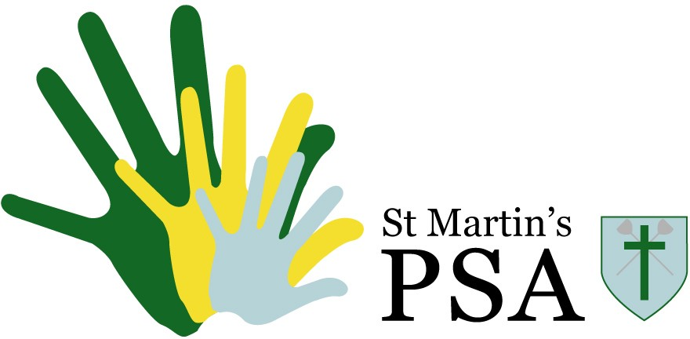
St Martins PSA
Treasurer use only
Request No. Received: Approved: Cost:

Reg. Charity No. 272330

Funding Request Form

Please use this form for all requests for PSA funding in whole or part.
We are really pleased to be able to support the school by paying for events, facilities or equipment, which are outside the normal school budget. Typically, requests should benefit as many students as possible. However, where there is a great need for a specific group of students, we are happy to consider this too.

Please return the completed form to the PSA by email at stmartinspsa@outlook.com or in the PSA letterbox outside the School Office.

Items for which PSA funding is required:

Why the items are needed (please included details on who would benefit and why the PSA should fund it):

Estimated cost of item:
Amount requested from:

Requested by:
Date:

Authorised by:
Date:

Notes:
- Items over £500 need to be authorised by the Executive Head teacher.
- Any requests will be considered by the PSA at their next meeting and the Secretary will contact you to inform you of the outcome of any decision.

